Name: _____________________________ ID: ____________

Department of Computer Science and Engineering
FINAL EXAMINATION
Summer 2013
CSE340: Computer Architecture

Total Marks: 70 Time Allowed: 2.20 hrs
- Answer ANY SEVEN questions.
- Return the question with your answer script
Question 1
- Define Compiler, Assembler and High Level Programming Language. 4.5
- Define ISA and ABI. 2
- What do you mean by Datapath, Memory hierarchy and Multi processor systems? Explain with appropriate figures. 3.5

Question 2
- What are the differences between RICS and CICS Architecture? 2
- Encode the following MIPS instructions. For each instruction, you should identify the format type (R, I, or J format): 4.5
  - sub $s0,$t0,$t1 # $s0 is register 16 and $t0 is register 8, op=0,function=22hex
  - beq $s1,$s2,100 # $s1 is register 17 and $s2 is register 18, op=4hex
  - sb $12, 2($3) # op=28hex
- In the following code segment f,g,h,i and j are variables. If the five variables f through j corresponds to five registers $s0 through $s4, what is the complied MIPS code for the below C is statement? 3.5
if (i==j) f=g+h; else f=g-h;
Question 3
- Explain Big Endian and Little Endian addressing with appropriate figures. 3 4
- Write a MIPS code to sum the series 1+5+9+…+N. You should use minimum number of registers to implement the MIPS code. 4
- What do you mean by zero and sign extension? 3

Question 4
- Convert -87.6875 into IEEE-754 single point floating point representation. Also show the hex equivalent of the representation. 5
- 0 00000111 10101100000000000000000 convert this to decimal value using IEEE754 32-bit floating point representation. 5

Question 5
- X=0100 0111 1101 0000 0000 0000 0000 0000₂ Y=1010 1110 1110 0000 0000 0000 0000 0000₂ representing single precision IEEE 754 floating-point numbers, Find X+Y and X-Y. 6
- Our favorite program runs in 10 seconds on computer A, which has a 4 Ghz clock. We are trying to help a computer designer build a computer, B, that will run this program in 6 seconds. The designer has determined that a substantial increase in the clock rate is possible, but this increase will affect the rest of the CPU design, causing computer B to require 1.2 times as many clocks cycles as computer A for this program. What clock rate should we tell the designer to target? 4
Question 6
- Define Combinational elements and State elements. 2
- Draw the Datapath for lw instruction and explain the execution steps. 5
- Explain Multicycle datapath control unit. 3
Question 7
- Compare between single cycle, multi cycle and pipelining processing with necessary diagrams. 4
- Explain different pipeline Hazards with appropriate figures. 6
Question 8
- Label the diagram where numbered 1 to 15. Write your answer in the answer script. 5

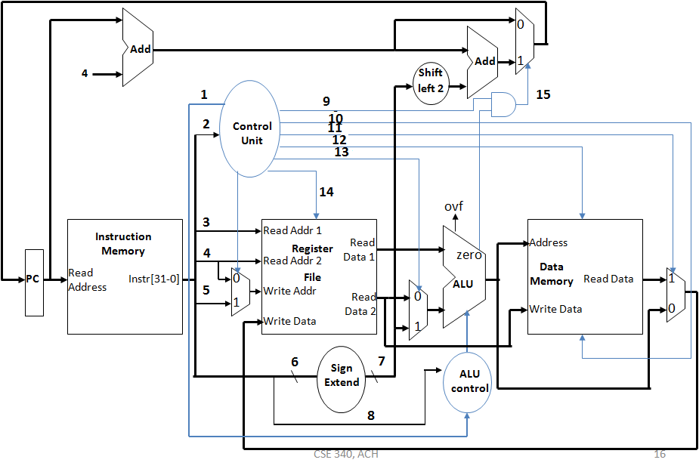
- How address of the next instruction is calculated in Jump instruction, explain with appropriate figure. 5

